**Assignment 2**

**Due Date:7 Jan,2022**

**Question 1**

Determine the traversals of the tree given below:

1. Preorder Traversal
2. Inorder Traversal
3. PostorderTraversal 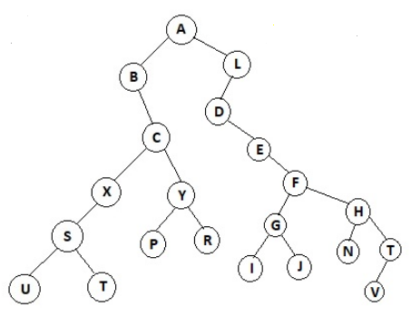

**Question 2**

Determine whether the given graph has

1. Euler circuit
2. Euler Path
3. Hamilton Circuit
4. Hamilton Path

